MINI-STM32 Manual
STM32F103RBT6(development board ) with 2.8" TFT-module

On-board resources:
* CPU: STM32F103RBT6; (LQFP64-pin, on-chip integrated 128K flash, 20KRAM, 16Bit A / D; PWM, CAN, USB and other resources)
*With a 2.8-inch TFT true color touch screen module, color touch module configuration ADS7843 (or RSM1843 instead) controller, support for a SD card (SPI mode) can be used to store pictures, in support of AT45DBxxx of a DATA FLASH (can be used for storage)
* USB interface, make USB experiment
* RS232 interface (ISP download), make RS232 communicate experiment
* AD adjuster
* standard ARM JTAG 20 pin
* A RTC in support, the four users LED lights, a power indicator light, a USB communication indicator, two user keys
* 8MHz crystal,32.768KHz crystal
* USB power supply
* All I / O port through the standard pitch leads 2.54MM
* Board Size: 82MM X 55MM

MINI-STM32 board have two type mode
1,Start from User Flash
2,Start from System Memory，come into ISP function
J1 | Start mode
1-2 | Start from User Flash
2-3 | Start from System Memory，come into ISP function

MINI-STM32 Board have a RS232 interface（UART1，RS232），UART1 support ISP download
Foot position | Functional Description | Foot Position | Functional Description
1 | NC | 2 | UART1_TXD
3 | UART1_RXD | 4 | NC
5 | GND | 6 | NC
7 | NC | 8 | NC
9 | NC

Reset Mode
JTAG emulate input reset signal

MINI-STM32 Power Supply
Used the USB cable as the Power supply，power supply current<200MA

USB interface：
Foot position | Functional Description | Foot position | Functional Description
+ | DP |  | DM
V | VBUS（power） | G | GND

Foot position | Functional Description | Foot position | Functional Description
J1 | Boot0 jumper | J2 | USB-B interface，USB communicate and power supply
J3 | USB data wire,  DM interface jumper | J4 | USB data wire,  DP interface jumper
JTAG | 20PIN JTAG emulate | RS232 | UART1 interface，ISP download
JP1 | TFT interface or IO interface jumper | JP2 | TFT interface, PB，PC interface
JP3 | JTAG mode or SWD mode jumper | JP4 | (PA，PB)IO

JP4 (PA，PB)IO
Foot position | Functional Description | IO | Foot position | Functional Description | IO
1 | PA0 | PA0 | 2 | PA1 | PA1
3 | PA2 | PA2 | 4 | PA3 | PA3
5 | PA4 | PA4 | 6 | PA5 | PA5
7 | PA6 | PA6 | 8 | PA7 | PA7
9 | PA8 | PA8 | 10 | PA9 | PA9
11 | PA10 | PA10 | 12 | PA11 | PA11
13 | PA12 | PA12 | 14 | PA13 | PA13
15 | PA14 | PA14 | 16 | PA15 | PA15
17 | PB0 | PB0 | 18 | PB1 | PB1
19 | PB2 | PB2 | 20 | PB3 | PB3
21 | PB4 | PB4 | 22 | PB5 | PB5
23 | PB6 | PB6 | 24 | PB7 | PB7
25 | 3V3 | 电源 | 26 | GND | 地

JTAG CN1
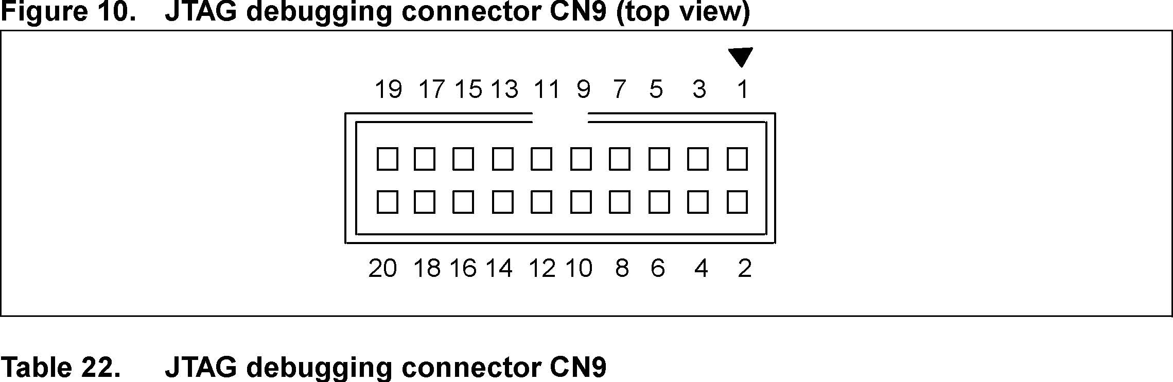
Pin number | Description | Pin number | Description
1 | 3.3V power | 2 | 3.3V power
3 | PB4 | 4 | GND
5 | PA15 | 6 | GND
7 | PA13 | 8 | GND
9 | PA14 | 10 | GND
11 | RTCK | 12 | GND
13 | PB3 | 14 | GND
15 | RESET# | 16 | GND
17 | DBGRQ | 18 | GND
19 | DBGACK | 20 | GND

TFT LCD interface
Foot position | Functional Description | IO | Foot position | Functional Description | IO | Foot position | Functional Description | IO
1 | 3V3 | power | 2 | GND | GND | 3 | DB00 | PE0
4 | DB01 | PE1 | 5 | DB02 | PE2 | 6 | DB03 | PE3
7 | DB04 | PE4 | 8 | DB05 | PE5 | 9 | DB06 | PE6
10 | DB07 | PE7 | 11 | DB08 | PE8 | 12 | DB09 | PE9
13 | DB10 | PE10 | 14 | DB11 | PE11 | 15 | DB12 | PE12
16 | DB13 | PE13 | 17 | DB14 | PE14 | 18 | DB15 | PE15
19 | CS | PC6 | 20 | RS | PD13 | 21 | WR | PD14
22 | RD | PD15 | 23 | RESET | RESET | 24 | EN | NC
25 | MISO | PC11 | 26 | INT | PC5 | 27 | MOSI | PC12
28 | LE | PB2 | 29 | SCLK | PC10 | 30 | F_CS | PC7
31 | TP_CS | PC8 | 32 | SD_CS | PC9

